RESOLUTION NO.__________

RE: CERTIFICATE OF APPROPRIATENESS UNDER THE
PROVISIONS OF THE ACT OF THE PENNSYLVANIA
LEGISLATURE 1961, JUNE 13, P.L. 282 (53
SECTION 8004) AND BETHLEHEM ORDINANCE NO.
3952 AS AMENDED.

WHEREAS, it is proposed to install signage, a new awning and graphics on the door at 420 Main St.

NOW, THEREFORE, BE IT RESOLVED by the Council of the City of Bethlehem that a Certificate of Appropriateness is hereby granted for the proposal.

Sponsored by:_

ADOPTED BY COUNCIL THIS DAY OF , 2016

President of Council

ATTEST:

City Clerk

HISTORICAL & ARCHITECTURAL REVIEW BOARD

The applicant proposes to install signage, a new awning and graphics on the door at Musselman Jewelers at 420 Main St.
APPLICATION #5:

Bethlehem Area Moravians
420 Main St.
Bethlehem, PA 18018

OWNER:

__________________________________________________________________________

The Board upon motion by Connie Glagola and seconded by Marsha Fritz adopted the proposal that City Council issue a Certificate of Appropriateness for the following:

- The sign above the storefront will be approx. 30” high x 96” long.

2. Painted aluminum with black background and gold leaf text and border.

3. Sign to be mounted into mortar joints.

4. Bracket mounted sign to be similar to Moravian Bookstore sign adjacent and to
be located on the right side of the façade also mounted into mortar joints.

5. Awning to be black fire retardant fabric with either a bold or creamy white letter
“M” on the sloped surface.

6. Vinyl text on the glass door will be gold with black outline.

7. Moravian star will have a frosted glass appearance.

8. The motion was unanimously approved.

__________________________________________________________________________

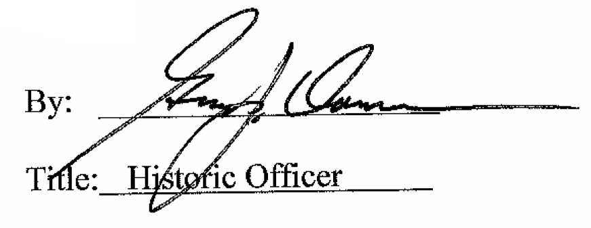

Date of Meeting: April 6, 2016

